Application for LY B. Tech Project
Project No. C5

Department: Computer Science
Department Thrust Area: Blockchain
Title: Smart Crowdfunding using Blockchain

Category: Departmental Internal
If External attach details with letter from the external organisation for permission to do project / thesis
Whether will receive finance from any agency: No
Objectives of the project in brief (attach separate sheet if required)
As of today, crowdfunding platforms have accountability and trust problems. In many cases, money from donors/philanthropists has gone into wrong campaigns and has been misused. Implementing a blockchain-based platform can bring in a change. With this project and blockchain smart-contracts, donors would be informed about the payments to be processed by the Fundraiser through request money forms. A smart contract helps to block the funds within blockchain until the campaign organizer makes progress in the campaign.
- With the help of our application people would be able to create campaigns to raise fund for natural calamities, start-ups or any other social/personal causes. Similarly, on other end general public can donate funds for these campaigns.
- Our application goal is to create a transparency between donors and the campaign organizers in the respect of how the money is spent and where it is spent.
- The organizers would not be able to spend the money without informing to the donors about the details of spending.
- We aim to accomplish decentralized crowdfunding application using blockchain and smart contracts.
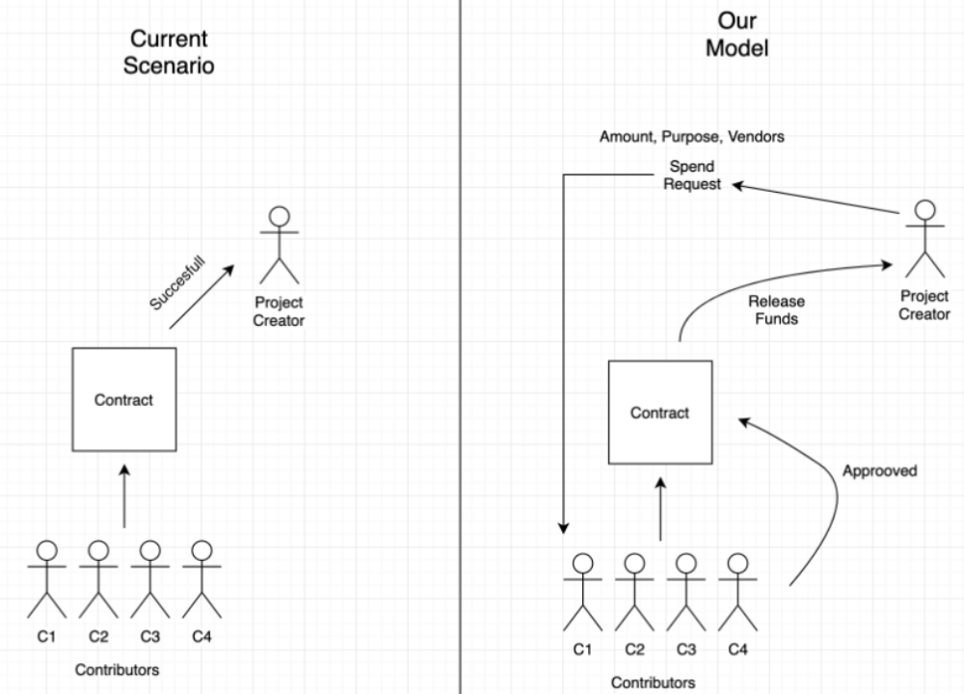
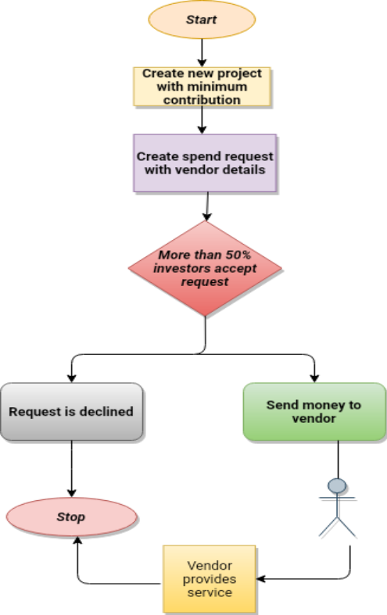
LITERATURE SURVEY:
Venturing Crowdfunding using Smart Contracts in Blockchain [1]: Referring to his paper, this paper proposes the blockchain based crowd funding by using which the platform can give a private, secure and decentralized path for crowdfunding. The main objective of this paper is to let investors contribute to any project effectively by creating smart contracts through which the contributors can have a control over the invested money and also both the project creators and investors can effectively make and reserve funding for the project. After deploying the project, a decentralized web app was created with a frontend for creating a new project, contributing to a project, creating a new request, approving a request and finalizing a request.
With the evolution of blockchain, this proposed work have a bright future and a large scope for improvement and evolution. We aim to progress further in an easier and safer way for all ideas that are achieved through the proposed crowdfunding application.

TECHNOLOGIES TO BE USED:
- Meta-mask
- Solidity (Smart-Contract)
- Web Development Technologies (Node.js, MERN stack)
- Ganache
- Truffle
- Web3.js

SCOPE:
- The project is to be limited for Relief Fund Raising initially. If the project goals are achieved before the deadline, we will then add the crowdfunding functionality for start-ups too.
- The project aims to notify all the donors where the payment for a particular amount is to be made by the Fundraiser but the project does not provide post-payment tracking of the funds for now.

Project Timeline:
https://docs.google.com/spreadsheets/d/1CQvcWP2IKCeO2VfgqQMUXBR1Hk2QLBz2/edit?usp=sharing&ouid=101915741093553514098&rtpof=true&sd=true

REFERENCES:
[1] Venturing Crowdfunding using Smart Contracts in Blockchain | IEEE Conference Publication | IEEE Xplore.
[2] Proposed Solution for Trackable Donations using Blockchain | IEEE Conference Publication | IEEE Xplore
We declare that the proposed work is based on our and / or others’ ideas which will be adequately cited and referenced in the reports. We also declare that we will adhere to all principles of intellectual property, academic honesty
Roll No. | Names of the students | Branch | Email Id and Mobile no. | Signature of the Student
1811008 | Urmil Jatin Chandarana | COMPS | urmil.c@somaiya.edu  8459700636 | 
1811023 | Dhairya Ashwin Mehta | COMPS | mehta.da@somaiya.edu  9833656812 | 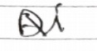
1921002 | Harshavardhan Rajesh Talele | COMPS | h.talele@somaiya.edu  9920054007 | 
1921006 | Niha Kamaluddin Shaikh | COMPS | niha.ks@somaiya.edu  9209175057 | 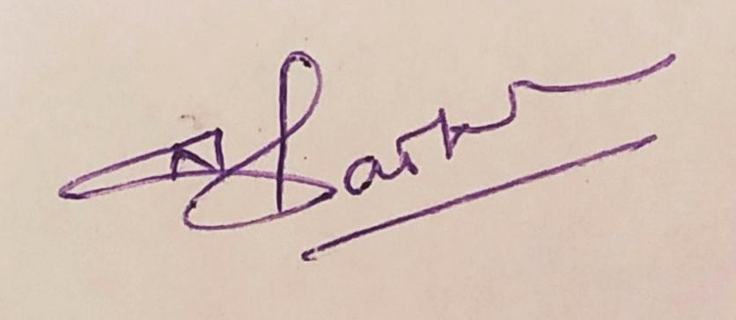
.
 | @Name | Dept. / organisation | Signature
Guide | Prof. Swapnil Pawar | COMPS/  KJSCE | Prof. Swapnil Pawar
@ In case of external guide give mobile no. and email id.

__________________________________
Date Signature of IRRC Committee Member/s
- All the student members of the group must have understanding in all respect towards the execution, completion and evaluation of project work
- Both guide and co-guide must have understanding in all respect towards the execution, completion and evaluation of project and will work as an examiner for all the intermediate examinations including final defense. The co-guide can be other than KJSCE.
- For interdisciplinary project there will be one Guide as principle investigator and there can be 1-2 co-guides depending upon the project.
- For interdisciplinary project there will be intermediate evaluation / final defense organised by the parent department of the guide.

Time line chart for project / thesis work completion
 | Task  (to be filled by the students at the time of IRRC approval) | Comment of guide about actual results / progress / level of work completed | Signature of Guide  / Co-guide  With date
July Second fortnight | Submit Initial Project Draft and Proposal
August First fortnight | Perform Literature Survey and other market requirements.
August Second fortnight | Perform detailed research on required resources and start courses related to the tech-stack involved.
Sept. First fortnight | Create Design Specifications and System designs
Sept. Second fortnight | Start Interface Designing alongside with implementation of Front-end development
Oct.  First fortnight | - Continuing with basic UI/UX and Front-End Scripting.  - Implement basic backend (Smart-Contracts, ETH-chain API calls) and related Unit Tests  (Basic Functionalities for Prototype model)
Oct. Second fortnight | - Continuation of Backend Development.  - Integrating Backend with Front-end and ETH Blockchain
Nov.  First fortnight | Buffer period to complete any pending work and performing all unit, modular and integration testing along with documentation  7th Semester Deliverable: Basic working prototype model
The objectives which will be achieved before VII semester examination:
- Perform Comprehensive Literature Review.
- Basic System and Interface designing.
- Backend Development along with Testing and related documentation.
- Integration of Front-End with Backend resulting in a basic working prototype model.

Time line chart for project / thesis work completion
 | Task  (to be filled by the students at the time of IRRC approval) | Comment of guide about actual results / progress / level of work completed | Signature of Guide  / Co-guide  With date
Jan. Second fortnight | Finalization of system model and all functionalities  (All UI and backend functionalities and improvements)
Feb.  First fortnight | - Implementing final UI/UX development with improvement  - Adding newly decided backend functionalities and improvements as suggested.
Feb.  Second fortnight | Continuing with the final system model development as above. (UI and backend) along with Unit, modular testing and documentations
March  First fortnight | - Integration of the final system Front-End with Backend and Test-ETH Blockchain  - Performing Integration and System testing with documentation
March  Second fortnight | - Writing research paper on the work done  - Performing remaining system tests along with other boundary checks.
April  First fortnight | - Buffer period to complete remaining work  - Focus on improving system performances and adding any suggestions.  - Correcting any issues found during testing
April  Second fortnight | - Buffer period to complete the work  - Correcting any issues found during testing and improvement phase.  - Finalizations of the deliverables.
The objectives which will be achieved before VIII semester final defense:
- Finalized System model with all documented functionalities.
- Development of final UI/UX and Backend along with final Integration.
- Performing different types of Tests and their documentation.
- Correcting any issues found during testing and focus on any improvements either suggested or thought of.
- Preparing research paper of the Project.

